Ice Core Paleoclimate Slide Set
These resources are available online at: http://www.ncdc.noaa.gov/paleo/slides/slideset/
Paleo Slide Set: Polar Ice Cores

Edge of the Greenland Ice Sheet
The Earth's poles are harsh, nearly uninhabitable places where the summer sun lights the ground for months at a time before going into hiding for the entire winter. Ask anyone what they think of Greenland or Antarctica, and the first thing that'll come to mind is ice, lots of it. And it is ice that draws paleoclimatologists literally to the ends of the earth in the quest for knowledge about where our planet has been, where it is, and where it might be going. At the edge of the Greenland Ice Sheet, the slowly moving ice nears the end of its journey. Soon, it will slide into a glacial river and melt. After a 30 km journey, the water and sediment you see here will finally complete a cycle that may have started thousands of years back in the ocean.  Photo Credits:  Kendrick Taylor  Desert Research Institute (DRI), University of Nevada-Reno. | 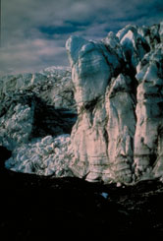  Click on above image to enlarge.  Download 4435 KB TIF Image
Paleo Slide Set: Polar Ice Cores

Midnight sun.
During the midnight sun, twilight keeps the Greenland Ice Sheet illuminated well into the early morning. Scientists have come here, to the interior of Earth's largest island, to unlock important clues about Earth's climatic history. Nearly two miles above sea level, the summit of the Greenland Ice Sheet is high, bleak, and as cold as it looks in this photo. During the short summer field season when scientists occupy nearby drilling sites, air temperatures range from -20 to 0 degrees C, but may drop as low as -40 degrees C.  Photo Credits:  Bruce Vaughn  Institute of Arctic and Alpine Research (INSTAAR), University of Colorado at Boulder. | 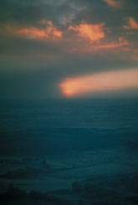  Click on above image to enlarge.  Download 2023 KB TIF Image

Paleo Slide Set: Polar Ice Cores

Map indicating where GISP2 site location.
The National Science Foundation-funded Greenland Ice Sheet Project 2 (GISP2) drill site is located near the ice sheet's summit. Ice sheets, as the elevational contours on this map suggest, are enormous dome-shaped glaciers that flow slowly outward from their center. The GISP2 site is located 30 km from the current summit of the ice sheet (where its European counterpart, the Greenland Icecore Project [GRIP] core was drilled), at a site where ice flow is minimal and the record of climatic conditions as reliable as possible.  Photo Credits:  Thomas Andrews from a map drawn by Sherry Palmer  GISP2 Science Management Office (GISP2 SMO), University of New Hampshire. | 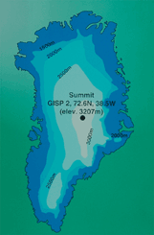  Click on above image to enlarge.  Download 1973 KB TIF Image

Paleo Slide Set: Polar Ice Cores

GISP2 Drilling Site
This is the GISP2 drilling site, located deep in the interior of Greenland at 72.6�N and 38.5�W at an elevation of 3207 m. The icescape is entirely flat and glistens brilliantly in the summer sun. The camp consists of the drill dome (easily identifiable in the center of the picture), a subterranean network of processing and storage trenches, the big house (not readily identifiable in this slide) where researchers eat and socialize, and accommodations for scientists. The site is accessed by LC-130 transport planes of the 109th TAG of the New York Air National Guard specially equipped with skis and wheels for landing both on the ice sheet of Greenland and the tarmac of home base.  Photo Credits:  Michael Morrison  , GISP2 SMO, University of New Hampshire. | 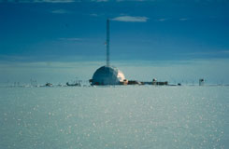  Click on above image to enlarge.  Download 1964 KB TIF Image

Paleo Slide Set: Polar Ice Cores

Layout of the sub-surface core processing line (CPL)
This figure shows the layout of the sub-surface core processing line (CPL), a network of trenches and rooms where cores are sampled, processed, and stored before shipment to the United States.  Photo Credits:  Mark Twickler  GISP2 SMO, University of New Hampshire. | 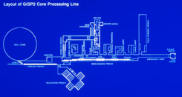  Click on above image to enlarge.  Download 1606 KB TIF Image

Paleo Slide Set: Polar Ice Cores

Weatherport
Researchers at the site could choose between weatherports (the semi-cylindrical structures consisting of tubular metal frames overlaid with insulatory tent materials) or tents. While the weatherports were equipped with plywood floors and oil heaters, they also had to be shared with up to 15 other scientists.  Photo Credits:  Kendrick Taylor  DRI, University of Nevada-Reno. | 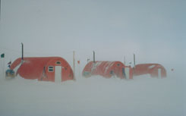  Click on above image to enlarge.  Download 1881 KB TIF Image

Paleo Slide Set: Polar Ice Cores

Tent city
Faced with this lack of privacy, many researchers opted for more private, but much colder, unheated tents such as these. During storms, the white sky and featureless white ice sheet made disorientation a distinct and dangerous possibility. It is hard to imagine a worse place to get lost than the unrelenting, unpopulated expanse of the Greenland Ice Sheet. Flag lines were placed along all major routes of travel around the camp to prevent researchers from losing their way during frequent whiteouts.  Photo Credits:  Kendrick Taylor  DRI, University of Nevada-Reno | 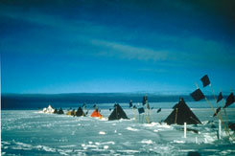  Click on above image to enlarge.  Download 1997 KB TIF Image

Paleo Slide Set: Polar Ice Cores

GISP Drill Dome
The GISP2 drill dome measures 32.5 m across, housing the drill and the lower part of its 37 m tower. The drill dome is connected via trenches and shafts to the subterranean core processing line.  Photo Credits:  Mark Twickler  GISP2 SMO, University of New Hampshire. | 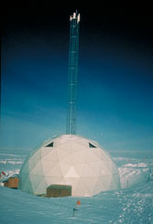  Click on above image to enlarge.  Download 2055 KB TIF Image

Paleo Slide Set: Polar Ice Cores

GISP2 drill from inside the drilling dome
This is a view of the GISP2 drill from inside the drilling dome. With each coring run approximately 5-6 m of ice is recovered. The drill is 20 m long and is lowered into the borehole on a 4 km long kevlar cable. Because ice at depth is under tremendous pressure and easily deforms, the hole created by the drill would close on itself from the pressure of the surrounding ice were nothing in the hole to supply back pressure. The GISP2 drillers fill the entire borehole to within 100 m of the surface with butyl acetate, an organic compound, to keep the hole from closing on itself. Clearly visible in the picture is the innovative carousel system that permits drilling to continue while ice core sections are being unloaded. After the drill is hauled to the surface, the core-filled barrel is rotated out of the drill assembly, emptied, and replaced with a fresh barrel. The drill can then be lowered into the hole for another coring run.  Photo Credits:  Mark Twickler  GISP2 SMO, University of New Hampshire. | 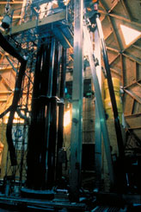  Click on above image to enlarge.  Download 2021 KB TIF Image

Paleo Slide Set: Polar Ice Cores

Cutter head and core barrel being examined.
The bottom part of an ice drill consists of a cutter head (the component that actually cuts the ice) and the core barrel, a hollow tube that accepts the ice carved out by the cutter head. The drill technician is brushing off the cutter head in preparation for another coring run. So many researchers were interested in analyzing ice from GISP2 that standard 10 cm diameter drills such as this were inadequate. Because of the great demand from the paleoclimatic community, the National Science Foundation contracted with the Polar Ice Coring Office to develop a drill capable of recovering cores 13.2 cm in diameter---providing nearly 75% more ice than standard cores extract. This bigger core size enabled scientists from 18 institutions to perform a veritable barrage of physical and chemical analyses on the GISP2 ice.  Photo Credits:  Kendrick Taylor  DRI, University of Nevada-Reno | 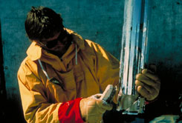  Click on above image to enlarge.  Download 2038 KB TIF Image

Paleo Slide Set: Polar Ice Cores

Core barrel being removed from drill
The drill assembly is lowered into the borehole on a heavy cable. Using electric power, the drill extracts a 6 m long section of ice. The core is then carefully raised to the surface. The newly-filled core barrel in this photo is gingerly being removed from the drill apparatus. Once the barrel is removed from the drill apparatus, it is replaced with another core barrel. The drill is then lowered into the borehole for another coring run.  Photo Credits:  Kendrick Taylor  DRI, University of Nevada-Reno | 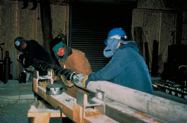  Click on above image to enlarge.  Download 1992 KB TIF Image

Paleo Slide Set: Polar Ice Cores

Extruding a core
Scientists extrude the core from its barrel with the utmost care. Any butyl acetate on the core surface is carefully cleaned off before sawing the ice into 2 m sections. The cloudy layers clearly visible in this 6 m core section were formed when dust fell onto the ice sheet and was entrained in the ice.  Photo Credits:  N/A  N/A | 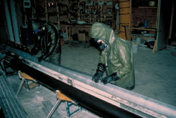  Click on above image to enlarge.  Download 2030 KB TIF Image

Paleo Slide Set: Polar Ice Cores

Summer and winter core layers
There are two primary sources for this dust. During the dry northern summer, particulates from Arctic Canada and coastal Greenland are carried by wind currents and deposited on the Greenland ice sheet. In addition to this seasonal influx of dust, gigantic volcanic eruptions anywhere on the globe can also spew enormous quantities of dust into the atmosphere. Eventually, if atmospheric conditions are right, some of this dust may find its way onto the Greenland ice sheet. These dust layers are extremely important because they have allowed scientists to date the GISP2 core more accurately than most previous cores.  Photo Credits:  Anthony Gow  United States Army Corps of Engineers, Cold Regions Research and Engineering Laboratory. | 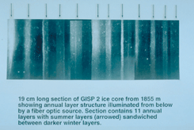  Click on above image to enlarge.  Download 2009 KB TIF Image

Paleo Slide Set: Polar Ice Cores

GISP2 cores span 200,000 years of climate history
On Thursday, July 1, 1993, GISP2 drillers struck rock, completing one of the longest environmental records (3053.51 m, over 200,000 yr of the Earth's climate history) ever obtained from an ice core. After 5 years of drilling, researchers from 18 United States educational and research institutions had finally achieved their goal of boring nearly two miles to the very bottom of the ice sheet. The cores in this photo show the sharp change from clear to silty ice that occurs at a depth of 3040.33 m. The transition is followed by alternating bands of silty and clear ice followed by progressively siltier ice until contact with bedrock at 3053.51 m. Researchers postulate that the silty ice formed when melting ice at the base of the sheet incorporated bedrock debris and refroze.  Photo Credits:  J. S. Putscher  GISP2 SMO, University of New Hampshire. | 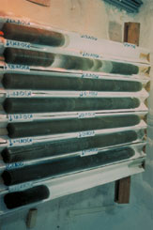  Click on above image to enlarge.  Download 1998 KB TIF Image

Paleo Slide Set: Polar Ice Cores

Core processing line
The temperature of the ice cores is never allowed to rise above -15 degrees C, partly to prevent microcracks from forming and allowing present-day air to contaminate the fossil air trapped in the ice fabric, and partly to inhibit recrystallization of the ice structure. Since summer temperatures in central Greenland are often higher than this, the core is moved immediately from the drill dome to a network of trenches beneath the snow surface known as the core processing line (CPL). The first stop in the CPL are these wooden trays where cores are stored before measurements are performed. This ice is from 1500 m and is clear with the exception of a few subtle seasonal dust bands.  Photo Credits:  Kendrick Taylor  DRI, University of Nevada-Reno | 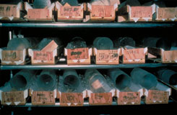  Click on above image to enlarge.  Download 1951 KB TIF Image

Paleo Slide Set: Polar Ice Cores

GISP2 science trench
This is the GISP2 science trench. The air temperature in the core processing line ranges from -35 degrees C in the early part of the field season to nearly -20 degrees C near the end. Working in these extreme temperatures requires heavy clothing: snowsuits, insulated boots, mittens (gloves if tasks requiring dexterity are being performed), and headgear. These scientists are also wearing special clean suits over their cold weather gear to prevent the core samples from becoming contaminated and ruining physical and chemical analyses done on the core. Some core analysis is done on-site in the core-processing line. The results of these tests help guide the course of subsequent sampling and analysis. Up to 50 m of core a day were processed through the CPL by an average staff of 12-15.  Photo Credits:  Mark Twickler  GISP2 SMO, University of New Hampshire. | 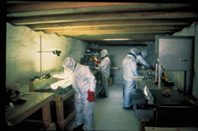  Click on above image to enlarge.  Download 1954 KB TIF Image

Paleo Slide Set: Polar Ice Cores

Cross section of how ice core is sectioned
As mentioned earlier, one of the major advantages of the revolutionary GISP2 drill is the size of the core it takes: 13.2 cm in diameter, containing 75% more ice than the 10 cm diameter cores taken at other high-latitude sites. This figure shows how the core is sliced up and different portions allotted to various analytical and archival purposes. Some ice procedures are consumptive, meaning their analysis requires the destruction of ice, while others have no effect upon the ice. Notice how much of the core is reserved for archival purposes, preserving this long record of earth history for future research.  Photo Credits:  Mark Twickler  GISP2 SMO, University of New Hampshire. | 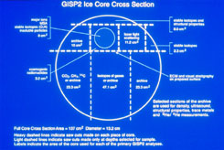  Click on above image to enlarge.  Download 2020 KB TIF Image

Paleo Slide Set: Polar Ice Cores

Electrical Conductivity Measurements (ECM) being conducted on the entire length of the core
A total of 42 types of measurements comprise the GISP2 research effort. These include: CO₂, O, and NO_{x} in air bubbles trapped in the ice; concentrations of major ions (Na⁺, NH₄⁺, K⁺, Mg⁺⁺, Ca⁺⁺, Cl⁻, NO₃⁻, SO₄²⁻⁾; cosmogenic isotopes ; stable isotopes; dust; electrical conductivity; and physical properties like crystal characteristics. The amount of data collected from the GISP2 core is truly astronomical, and it is possible in this presentation to introduce only a fraction of the body of knowledge gained during this massive effort.  Analyses that are costly or time-consuming can only be performed on selected segments of ice. Others like Electrical Conductivity Measurements (ECM, pictured here) are done on the entire length of the core. ECM is a fast and high-resolution way of measuring ice acidity. Two electrodes are drawn along the surface of the ice core while the electrical resistance (which varies as a function of acidity) between them is measured.  ECM is important for three reasons. First, it is well suited to detecting volcanic events in the core record. Volcanic eruptions emit large amounts of sulfur gases that react in the atmosphere with water to produce sulfuric acid (H₂SO₄). Given the right atmospheric conditions, some of this acid-enriched moisture may be transported to Greenland and precipitated onto the Greenland Ice Sheet, where it is incorporated into the glacier. These volcanic events often appear in the ECM record as large values reflecting high acid content because of the SO₄²⁻. Secondly, ECM is relatively easy to measure and is performed on the entire length of the core at a resolution of a few millimeters. Scientists look at ECM data to determine the location of interesting or significant climatic events that warrant further analyses, which ensures that researchers spend their time and money as effectively as possible. Finally, ECM varies seasonally, providing a high-resolution dating mechanism that, in conjunction with measurements of dust concentration and visual counting of annual dust bands (visual stratigraphy), allows the GISP2 core to be dated with unprecedented accuracy.  Photo Credits:  Mark Twickler  GISP2 SMO, University of New Hampshire. | 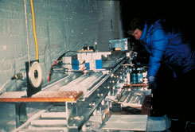  Click on above image to enlarge.  Download 2053 KB TIF Image

Paleo Slide Set: Polar Ice Cores

ECM variations based on data from a 2.4 m section of ice from approximately 100 m below the surface.
This figure shows how ECM varies annually and how this signal can be used to date the core. Remember that ECM is a way of gauging ice acidity. Dust from Arctic Canada and Greenland is alkaline, so precipitation deposited on the ice sheet during dusty periods is less acidic than precipitation deposited at other times. Dusty Arctic summers show up as lower readings in the ECM record. Scientists correlate large ECM peaks with historical records of volcanic eruptions. The 1660 eruption of Katla in Iceland and the 1667 eruption of Japan's Tarumani appear in this core segment. The volcanic signal in the ECM record greatly improves dating accuracy by providing absolute dates, unambiguous benchmarks upon which a reliable core chronology depends. ECM and other parameters that vary seasonally such as dust concentration, δ¹⁸O, and visual stratigraphy have been used to date the core to 40,000 yr B.P. with an estimated age error of �10%; currently, age models are being used to provisionally date the deepest core, and work is continuing to extend this dating to even greater depths.  Photo Credits:  Kendrick Taylor  DRI, University of Nevada-Reno | 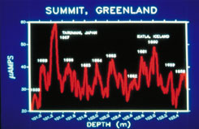  Click on above image to enlarge.  Download 1959 KB TIF Image

Paleo Slide Set: Polar Ice Cores

Signal of a 1479 A. D. eruption of Mt. St. Helens using data from Fiacco et al. (1993)
Volcanic eruptions evident in the ECM record direct scientists to particular core segments for further research. Researchers found a clear signal of a 1479 A. D. eruption of Mt. St. Helens (first identified in ash deposits in the Pacific Northwest and dated using tree rings) in both the particulate (dust) and sulfate (SO₄²⁻) records. As you can see from this photo of Mt. St. Helens' 1980 eruption, explosive volcanoes (as opposed to shield volcanoes like those in the Hawaiian Islands) hurtle vast quantities of ash high into the atmosphere. Just as ash from the 1980 eruption was deposited thousands of miles from the volcano, ash from the 1479 eruption was rapidly carried all the way to the Greenland Ice Sheet--probably in less than a week--leaving the particulate layer evident in the graph. Why doesn't the sulfate peak coincide with the particulate peak? In powerful eruptions like these, the volcano's plume of ash and gases may extend several miles into the sky, piercing the stratosphere. Sulfate aerosols in the plume are extremely light and take several months (and in the case of eruptions like Mt. Pinatubo in 1991, several years) to precipitate. GISP2 researchers estimate that the peak in sulfate deposition occurred 3-5 months after the eruption. That environmental events so far in the past can be identified with such clarity demonstrates why scientists go literally to the ends of the earth to extract ice cores.  Photo Credits:  Thomas Andrews  NOAA Paleoclimatology Program | 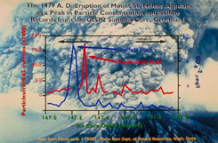  Click on above image to enlarge.  Download 1981 KB TIF Image

Paleo Slide Set: Polar Ice Cores

Fluctuations of ice conductivity
While ECM measurements highlight volcanic events and provide a seasonal signal that aids in dating the core, they also provide information about past climate. Just as ECM varies seasonally because dusty summers result in lower ECM readings, windy and dusty periods in the Earth's climatic history appear in the ECM record as periods of near-zero readings. This figure demonstrates the close correlation between cold climatic events (the Younger Dryas and Wisconsin Glacial [the Wisconsin is the term used in North America to refer to the last full ice age], in blue) and low ECM readings. Paleoclimatologists postulate that dust fluxes increase during colder periods because the glacial atmosphere is drier. Since dust stays in the air longer when the climate is dry, it is transported greater distances in the atmosphere, resulting in increased dust fluxes to sites like the Greenland Ice Sheet that are without local dust sources.  Photo Credits:  Graphic by Thomas Andrews. Data from Kendrick Taylor  DRI, University of Nevada-Reno | 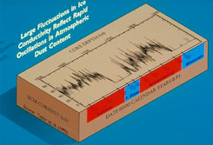  Click on above image to enlarge.  Download 2047 KB TIF Image

Paleo Slide Set: Polar Ice Cores

Calcium Concentrations
While ECM data can provide many important insights regarding past climate, 41 other analyses provide even more compelling paleoclimatological data. Calcium concentrations, like ECM, serve as a proxy measurement of dust flux onto the ice sheet. Glacial periods are marked by high calcium concentrations, while warmer periods are notable for very low calcium concentrations. As you can see from this slide and the previous one, the climatic regime underwent extremely rapid transitions during the period from 18,000 to 10,000 yr B. P.  Photo Credits:  Graphic by Thomas Andrews. Data from Paul Mayewski and others.  University of New Hampshire. | 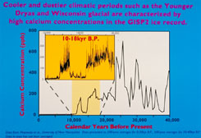  Click on above image to enlarge.  Download 2061 KB TIF Image

Paleo Slide Set: Polar Ice Cores

The ratio between the heavier H218O and lighter H216O water molecules in the ice
The ratio between the heavier H₂¹⁸O and lighter H₂¹⁶O water molecules in the ice is expressed as the departure from a standard --δ ¹⁸O=1000x(¹⁸O/¹⁶Oice -¹⁸O/¹⁶O std). Snow falling on the Greenland Ice Sheet under colder temperatures is more negative, that is it contains more of the light H₂¹⁶Omolecules. Thus, a plot of the δ¹⁸O of snow versus temperature shows an excellent correlation. Since δ¹⁸O is primarily temperature-dependent, it serves as a paleothermometer providing important information about past climate.  Photo Credits:  Graphic produced by Thomas Andrews using data from Johnsen et al. (1989)  NOAA Paleoclimatology Program | 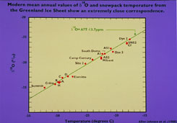  Click on above image to enlarge.  Download 2099 KB TIF Image

Paleo Slide Set: Polar Ice Cores

Delta 18O and accumulation for 10,000-17,400 yr B.P.
This figure shows two important proxy measurements: δ¹⁸O and accumulation for 10,000-17,400 yr B. P. As mentioned earlier, δ¹⁸O acts as a paleothermometer; accumulation, on the other hand, is a measure of annual layer thickness normalized to account for the compression of ice layers at depth and corrected for ice flow dynamics. It is thus an approximate measure of past precipitation.  Notice how (as the ECM and calcium data suggested) the climatic regime quickly shifted from cold to warm phases during the turbulent glacial-interglacial transition. Researchers have found that major climatic changes such as the switch from the cold Younger Dryas event to the warm Holocene epoch may have occurred over just a few years, suggesting that climate during the last glacial period was inherently unstable and subject to rapid fluctuations. In fact, the last 10,000 years have witnessed the most consistent and stable climate in the 200,000 Greenland ice record. Note however, that this same last 10,000 years appears to have been less stable at lower latitudes.  Photo Credits:  Thomas Andrews using data from Grootes and Alley  Pieter Grootes, University of Washington & Richard Alley, Pennsylvania State University | 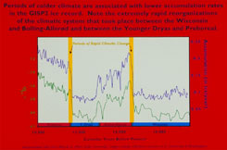  Click on above image to enlarge.  Download 1990 KB TIF Image

Paleo Slide Set: Polar Ice Cores

Thin wafers of ice for core viewed between crossed polarizers.
Researchers also study the physical properties of the GISP2 ice. Crystal size and orientation, temperature of the borehole at the time of drilling, and ice density all hint at how the ice formed and the conditions of its stay in the ice sheet.  By examining thin wafers of ice between crossed polarizers, scientists determine the orientation, shape, and size of the ice crystals. A crystal's orientation is indicated by its color under polarized light, and is used to determine whether a given ice segment has undergone deformation significant enough to distort the ice record (for example, researchers originally located a period of rapid and intense climate change in the last interglacial; ice crystal research, however, revealed that sections of the ice segments upon which these findings were based may have been disturbed or removed due to shearing). In the upper part of the GISP2 core, crystal size increases with depth; this segment from 333 m is made up of mid-sized crystals. Minute air bubbles appear in the photo as small round inclusions, the most visible being in the large orange crystal near the center of the photo. These samples of fossil air provide scientists and policy-makers with direct evidence of past atmospheric composition for the last 200,000 years, documenting the effects that modern man has had on Earth's atmosphere and providing information that is crucial to informed scientific and political debates about greenhouse warming.  Photo Credits:  Anthony Gow  United States Army Corps of Engineers, Cold Regions Research and Engineering Laboratory. | 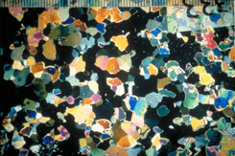  Click on above image to enlarge.  Download 2004 KB TIF Image

Paleo Slide Set: Polar Ice Cores

Non-Sea Sulfate and Nitrate Concentrations since 1900
Records of recent human activities are also stored in the Greenland Ice Sheet. Research from the top layers of the ice sheet shows how concentrations of nitrates (NO₃₋) and non-sea salt sulfates have increased dramatically since 1900 A. D. Sulfates and nitrates are released when fossil fuels are burned. They react with water in the atmosphere to form sulfuric and nitric acids (H₂SO₄ and HNO₃, respectively), two of the leading components of acid rain (rain is naturally mildly acidic; the term acid rain is used to refer to precipitation with acidity higher than that occurring naturally). It is one of the great ironies of contemporary climatology that the huge quantities of sulfates released into the air by fossil-fuel burning may be helping to counteract the so-called Greenhouse Effect, the warming of the atmosphere anticipated because of increased carbon dioxide concentrations emitted during the very same burning of fossil fuels. One of the driving forces behind paleoclimatic research is the desire to gain a greater understanding of the climate system in the hopes of anticipating and/or preventing the possible adverse effects human activities may have on the environment. If anything is to be learned from the GISP2 project, perhaps it is this: Earth's climate has been very unstable in the past, and our understanding of the climate system is currently not advanced enough to know what caused this instability. Is it possible that the activities of human beings could usher in yet another era of climatic instability?  Data from GISP2 and dozens of other ice cores from polar and alpine areas are important tools in the search for answers to these crucial questions.  Photo Credits:  Graphic produced by Thomas Andrews using data from Mayewski et al. (1986 and 1990).  NOAA Paleoclimatology Program | 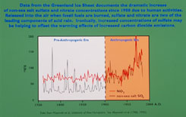  Click on above image to enlarge.  Download 1905 KB TIF Image

Paleo Slide Set: Polar Ice Cores

Snowcats carry cores to transport planes.
While much has already been learned from the GISP2 project, it will be years before the results from all 42 analyses from the entire 3000+ m core will be completed. To ensure that these pieces of ice could continue to tell their stories, the ice cores were packed into insulated boxes and dragged by these snowcats to New York Air National Guard transport planes for the long trip to the United States. Once in the United States, the ice will be allotted between its final destinations: laboratory analysis by the GISP2 participants, or storage at the National Ice Core Laboratory storage facility in Denver, Colorado.  Photo Credits:  Kendrick Taylor  DRI, University of Nevada-Reno. | 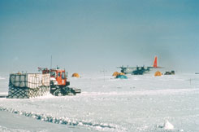  Click on above image to enlarge.  Download 1988 KB TIF Image

Paleo Slide Set: Polar Ice Cores

National Ice Core Laboratory (NICL)
Refrigerated vans transported the core boxes from the runway to the GISP2 headquarters at the University of New Hampshire. Eventually, the entire GISP2 core was placed in reflective cardboard canisters like these and stored at the National Ice Core Laboratory (NICL), a state-of-the-art cold storage facility jointly sponsored by the National Science Foundation, the United States Geological Survey, and the University of Colorado, Boulder.  Photo Credits:  Kendrick Taylor  DRI, University of Nevada-Reno. | 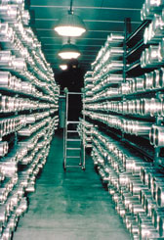  Click on above image to enlarge.  Download 2059 KB TIF Image

Paleo Slide Set: Polar Ice Cores

Drs. Meier and Alley logging the core's annual layers and bubbliness at the NICL..
NICL is not just a storage facility. Rather, think of it as an archive, a library of sorts where scientists like the University of Colorado's Mark Meier and Pennsylvania State University's Richard Alley come to study crucial chapters in the Earth's climatic history. The purpose of NICL is to ensure that ice cores like those from GISP2 will continue to enlighten our understanding of our planet's past, present, and future climate system. (Note the annual dust layers visible in this core segment).  Photo Credits:  Ken Abbott  Office of Public Relations, University of Colorado, Boulder | 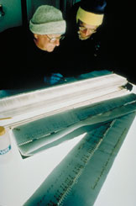  Click on above image to enlarge.  Download 1995 KB TIF Image

Paleo Slide Set: Polar Ice Cores

Antarctic ice
On the other end of the Earth, scientists search the vast icy expanses of Antarctica for more information about our planet's past.  Photo Credits:  Nancy Weiner  INSTAAR | 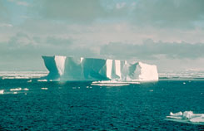  Click on above image to enlarge.  Download 1938 KB TIF Image

Paleo Slide Set: Polar Ice Cores

3-D image of Vostok region
With an average annual temperature of -55 degrees C, Vostok Station is one of the most frigid places on Earth. Antarctic topography is dominated by enormous ice domes seated atop bedrock. This 3-D image shows Vostok and sites where shallower cores have been drilled. Vostok is located 3490 m above sea level at 78ºS, 107ºE. With accumulation rates significantly lower than in Greenland, ice at Vostok has piled up much more slowly. Indeed, ice at the bedrock contact over 3500 m below Vostok Station is estimated to be over 500,000 years old.  Photo Credits:  Todd Sowers  Lamont-Doherty Earth Observatory (LDEO), Columbia University, Palisades, New York. | 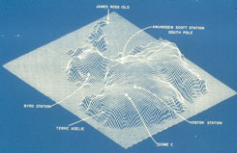  Click on above image to enlarge.  Download 1952 KB TIF Image

Paleo Slide Set: Polar Ice Cores

Vostok Site
The Vostok site was chosen by the Soviet Union for the deep coring possibilities it offered. French and, later, American scientists became interested in the Soviet research and began to participate in coring activities at the site. This panoramic photo of Vostok Station shows the layout of the camp. The striped building on the left is the power station while the striped building on the right is where researchers sleep and take meals. The building in the background with the red- and white-striped ball on top is the meteorology building. Caves were dug into the ice sheet for storage, keeping cores at an ideal -55 degrees C year round.  Photo Credits:  Todd Sowers  LDEO, Columbia University, Palisades, New York. | 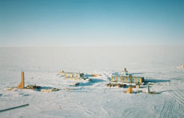  Click on above image to enlarge.  Download 1937 KB TIF Image

Paleo Slide Set: Polar Ice Cores

Deep drilling at Vostok
Deep drilling at Vostok was begun by the Soviets in 1980. After five years of coring, a stuck drill brought the 3G core, whose shelter is shown here, to a halt. Chemical analysis of air bubbles trapped in the 160,000 year record contained in this 2202 m core gave scientists their first long look at the past composition of Earth's atmosphere.  Photo Credits:  Todd Sowers  LDEO, Columbia University, Palisades, New York. | 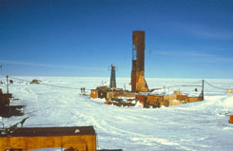  Click on above image to enlarge.  Download 1961 KB TIF Image

Paleo Slide Set: Polar Ice Cores

Vostok Climate Records
The Vostok core illustrated for the first time the strong correlation between paleotemperature and the concentration of greenhouse gases in the atmosphere. This figure shows how concentrations of carbon dioxide (CO₂) and methane (CH₄) have moved in tandem with paleotemperatures derived from the stable isotope record. The mechanisms of these relationships are poorly understood, and it is not known with any certainty whether increased temperatures are, to use an old paradox, the chicken or the egg. To what extent did increased temperatures bring about higher greenhouse gas concentrations? On the other hand, to what extent did higher greenhouse gases cause greater radiative warming of the Earth's atmosphere? To paleoclimatologists hoping to provide answers about global climate change (global warming), this has sparked intriguing scientific debate.  Photo Credits:  Todd Sowers  LDEO, Columbia University, Palisades, New York. | 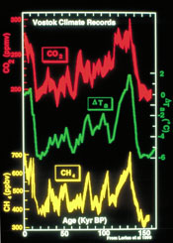  Click on above image to enlarge.  Download 3848 KB TIF Image

Paleo Slide Set: Polar Ice Cores

Methane Records
One of the major goals of paleoclimatologists is to extract climatic information from as many sites on the globe as possible. The more information we have about past climate, the clearer the picture gets. Since snow accumulates more slowly in Antarctica, records from Vostok do not have quite the temporal resolution of Greenland cores. As you can see from this graph, however, measurements of methane concentration from the GRIP (the European counterpart to GISP2) and Vostok cores agree very well in broad terms, illustrating large-scale climatic events such as the Younger Dryas cold event at ~11,000 yr B. P.  Photo Credits:  Thomas Andrews  NOAA Paleoclimatology Program | 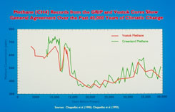  Click on above image to enlarge.  Download 1925 KB TIF Image

Paleo Slide Set: Polar Ice Cores

Measurements of Greenhouse Gases
The most alarming finding from the initial wave of Vostok research is presented here: Carbon dioxide (CO₂) concentrations (as measured atop Hawaii's Mauna Loa) are currently at their highest levels of the past 160,000 years. As shown earlier, CO₂ levels are generally high during warm interglacial periods such as the last interglacial from ~110,000 to ~130,000 yr B. P. At the end of the last ice age (~15,000 yr B. P.), CO₂ levels increased dramatically, reaching a level of ~280 ppmv (parts per million by volume) in the present millennium. Another Antarctic record, the Siple core, documents a rapid increase in CO₂ levels since the early 1800s due to anthropogenic (man-made) impacts, primarily the burning of fossil fuels. Direct measurements of atmospheric CO₂ have been made at Mauna Loa, Hawaii since the late 1950s. Vostok, Siple, and Mauna Loa create a composite picture of the enormous impact human activities have had on the natural environment, documenting a two-fold increase in CO₂ in the last 15 kyr. Climatologists and policy-makers alike are struggling to understand and prevent the rapid climate change that future increases (anthropogenic or otherwise) in CO₂ levels may cause.  Photo Credits:  Thomas Andrews  NOAA Paleoclimatology Program | 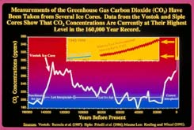  Click on above image to enlarge.  Download 4392 KB TIF Image

Paleo Slide Set: Polar Ice Cores

International team of scientists involved with Vostok
Science demands cooperation. By working together, these French, Russian, and American scientists were able to accomplish their goal: the long segments of ice they so proudly hold symbolize this sense of cooperation. Just as researching the Earth's climatic history requires collaboration between different individuals and different nations, preparing scientific, political, and social solutions for Earth's climatic future demands a level of cooperation far beyond that currently existing. While different nations and different peoples draw lines of separation and division on the globe, we all must realize that we share one, single planet, and that its destiny, good or bad, is the destiny of us all.  Photo Credits:  Todd Sowers  LDEO, Columbia University, Palisades, New York. | 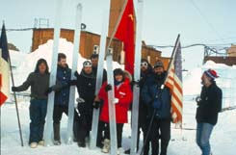  Click on above image to enlarge.  Download 1981 KB TIF Image

